SUPPORTING INFORMATION
Additional supporting information may be found online in the supporting information tab for this article.
List of information available
Table 1-SI: Perfusate composition.
Figure 1-SI: study recruitment flowchart
Figure 2-SI: vascular flows during NMP: (A) hepatic artery and (B) portal vein.
Figure 3-SI: IL-6 (A) and IL-10 (B) perfusate concentration during NMP.
Figure 4-SI: electron micrographs of liver samples after cold ischemia storage; (A) swollen mitochondria in hepatocytes from group CS; (B) magnification of the previous panel; (C, D) swollen mitochondria in hepatocytes from group NMP.
Figure 5-SI: electron micrographs of CS liver samples after cold ischemia storage; (A, B) cytoplasmic lipid droplets; (C, D) biliary poles with dense bodies.
Figure 6-SI: electron micrographs of liver samples after cold ischemia storage showing reduced Disse spaces (A: CS liver; B: NMP liver) and non-activated Kupffer cells (C: CS liver; D: NMP liver).
Figure 7-SI: electron micrographs of CS liver samples 2 hours after implantation; (A, B) mitochondrial swelling; (C, D) lipid droplets.
Figure 8-SI: electron micrographs of CS liver samples 2 hours after implantation: (A) numerous dense bodies in the biliary pole; (B) damaged vessel; (C) activated Kupffer cell; (D) infiltrating neutrophil.
Figure 9-SI: electron micrographs of NMP liver samples 2 hours after implantation: (A, B) mitochondria of normal size; (C, D) reduced lipid droplets

Table 1-SI. Perfusate composition.
COMPONENTS | VOLUME
ABO-compatible red blood cells concentrate | 750 mL
Gelofusine® (Braun, Melsungen, Germany) | 1000 mL
Human Albumin 200 g/L (Albital®, Kedrion, Barga (LU), Italy) | 100 mL
Parenteral nutrition (Plusflex®, Braun, Melsungen, Germany) | 10 mL
Multivitamins intravenous (IV) solution (Cernevit®, Italy) | 10 mL
Metronidazole IV solution 5mg/mL (Baxter, Rome, Italy) | 40 mL
Cefazolin 1000 mg (Teva Italia, Milan, Italy) | 10 mL
Fluconazole 100 mg (Fresenius Kabi Italia, Verona, Italy) | 50 mL
Fast acting Insulin 100 UI/ml (Actrapid®, Denmark) | 20 mL
Calcium Gluconate IV solution 10% (Galenica Senese) | 40 mL
Sterile water | 50 mL
Sodium chlorate 0.9% solution (Fresenius Kabi Italia) | 150 mL
Sodium bicarbonate 8.4% solution (Monico, Venice, Italy) | 30 mL
Heparin 25,000 units (Epsoclar®, Hospira Italy, Naples, Italy) | 5 mL
Total volume | 2265 mL

Figure 1-SI. Study flowchart
CEFEMA Flowchart Sep. 2016

Assessed for eligibility (n=83)
September 2016 – April 2017

EXCLUDED (n=15)
- Not meeting transplantability inclusion criteria during pre-transplantation assessment (n=11)
- Refused to participate (n=4)

Randomized in CEFEMA control group. LT with graft from donor > 70 years old after standard cold storage
(n=10)
Randomized in CEFEMA study group. LT with graft from donor > 70 years old after Ex-situ NMP of the graft
(n=10)

Suitable for enrollment in the CEFEMA Study
(n=35)
Excluded (n=33) LT with graft from donor < 70 years old.

Enrollment (n=68)
September 2016 – April 2017

LT with graft from donor older than 70 years old not randomized in the CEFEMA study because study completed by the time of transplantation (n = 15)

Allocation

Follow-Up
Until November 2017
(n=1) death due to fungal sepsis
(n=1) re-LT for graft loss due to hepatic artery thrombosis

Figure 2-SI. Vascular flows during NMP: (A) hepatic artery and (B) portal vein.

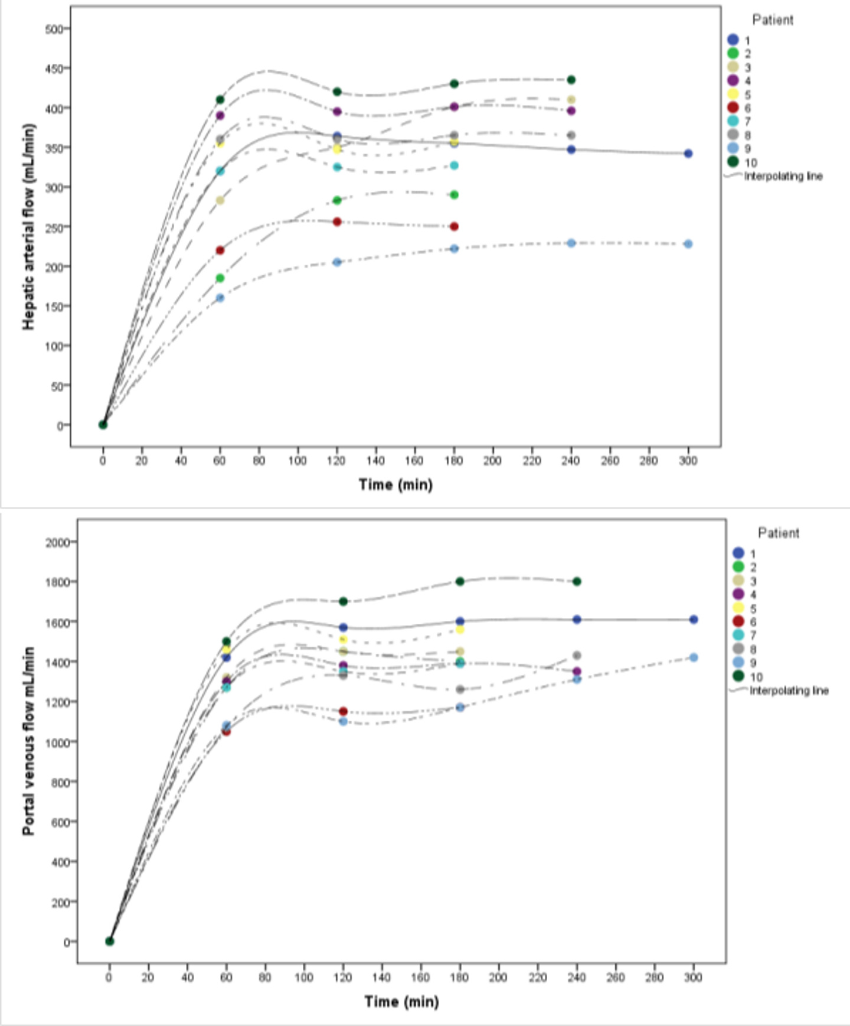

Figure 3-SI. IL-6 (A) and IL-10 (B) perfusate concentration during NMP.
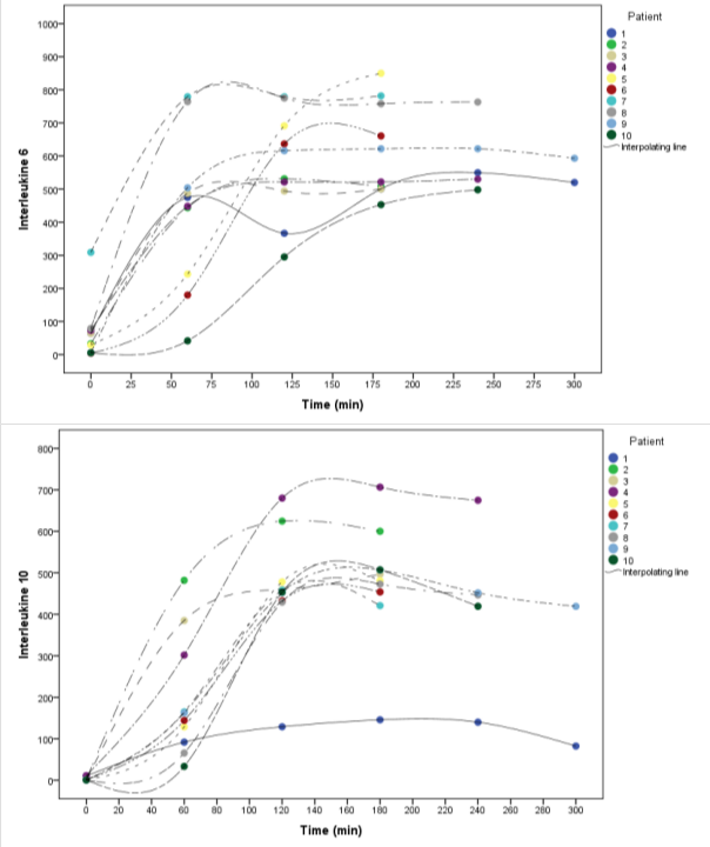
Figure 4-SI. Electron micrographs of liver samples after cold ischemia storage. A) Swollen mitochondria in hepatocytes from group CS; B) Magnification of the previous panel; C, D) Swollen mitochondria in hepatocytes from group NMP.
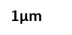


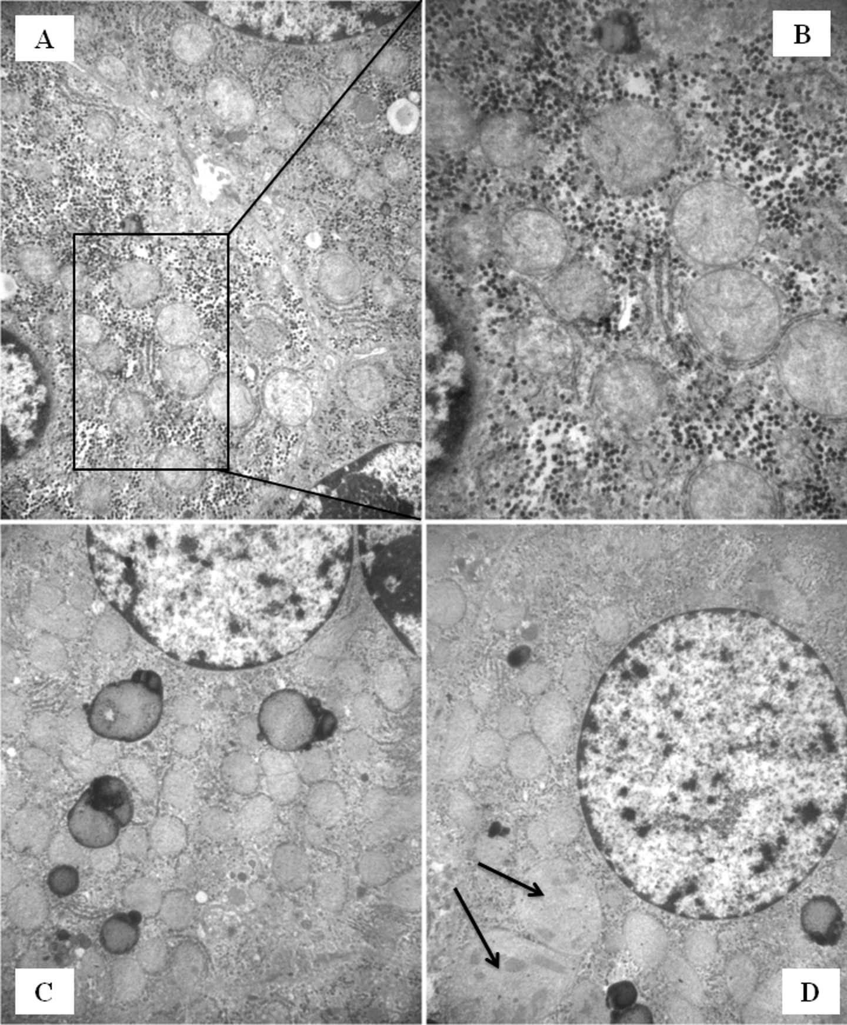
0,45µm

Figure 5-SI. Electron micrographs of CS liver samples after cold ischemia storage; (A, B) Cytoplasmic lipid droplets; (C, D) biliary poles with dense bodies.


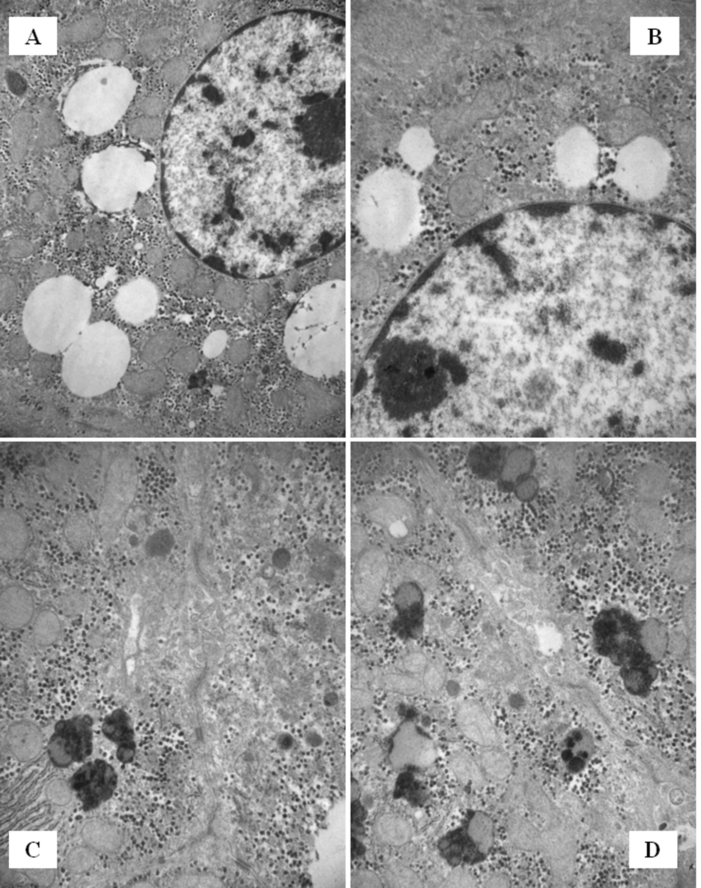
0,7µm
0,7µm
0,7µm

Figure 6-SI. Electron micrographs of liver samples after cold ischemia storage showing reduced Disse spaces (A: CS liver; B: NMP liver) and non-activated Kupffer cells (C: CS liver; D: NMP liver).




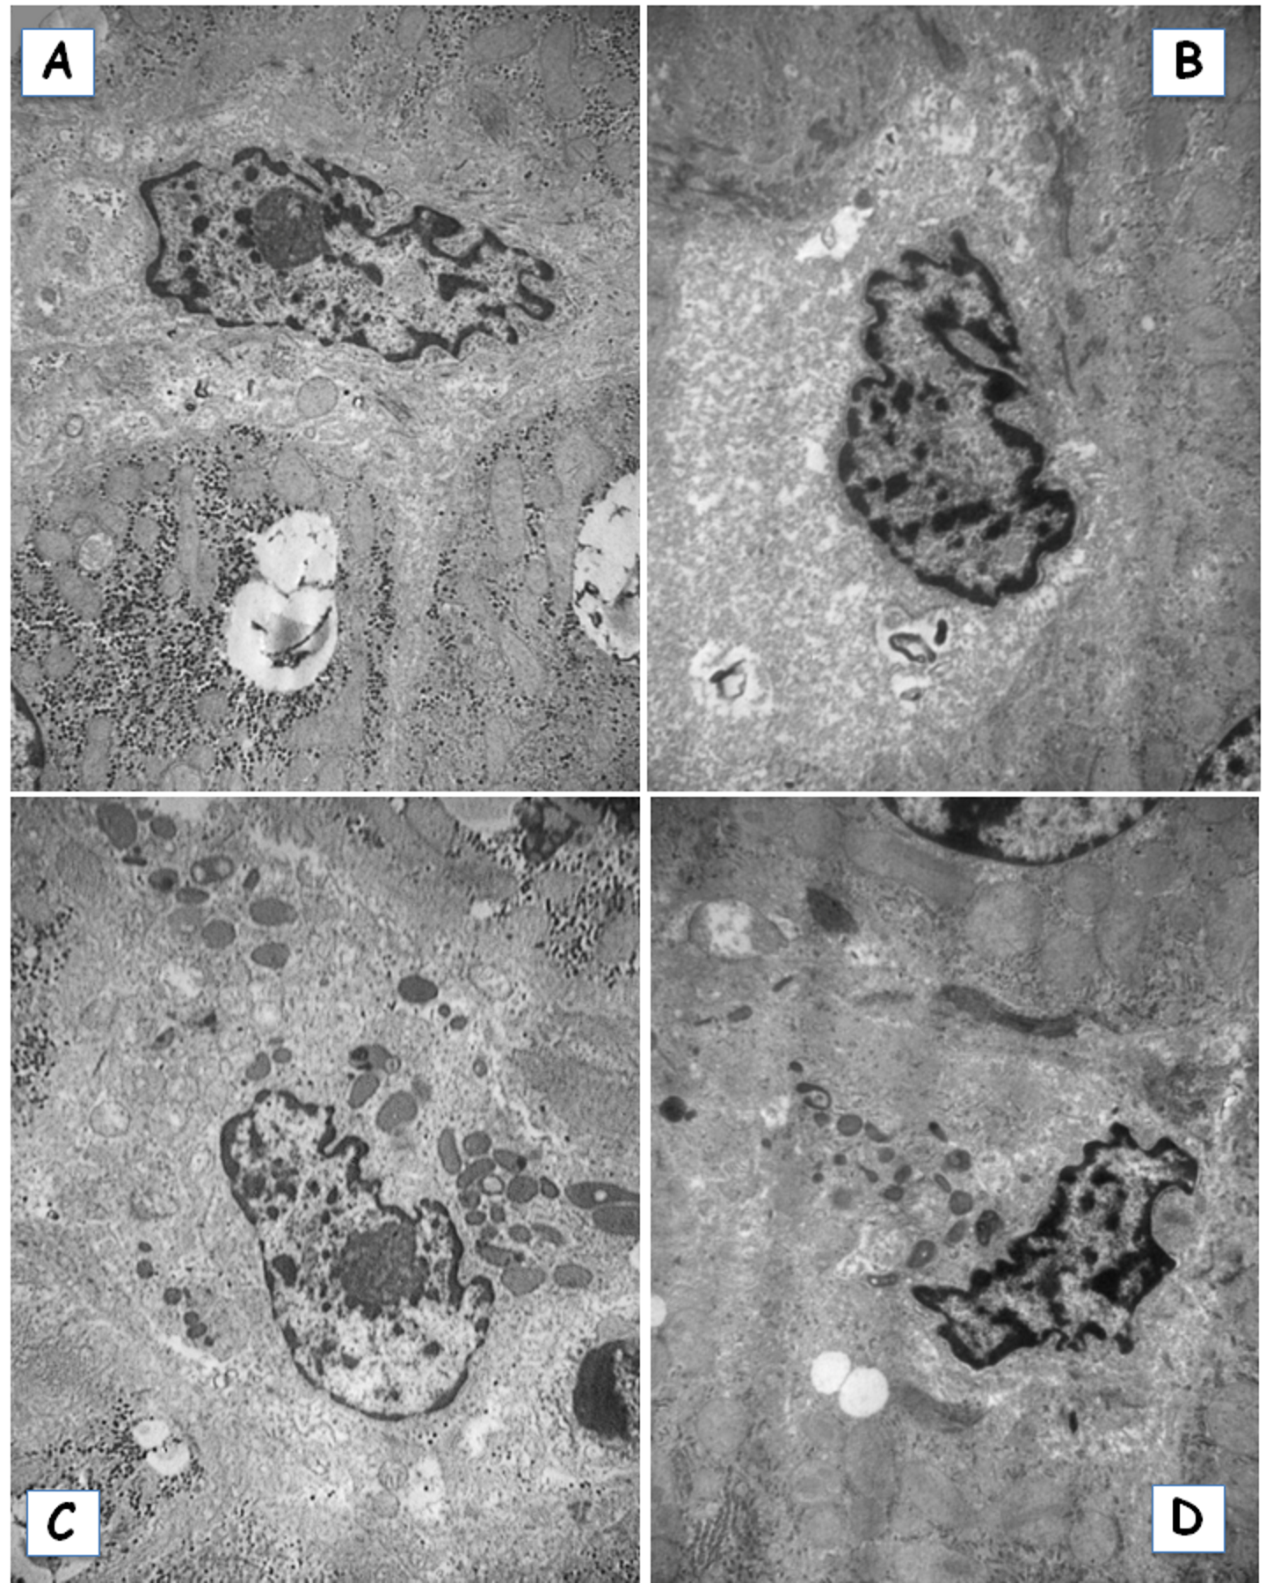

Figure 7-SI. Electron micrographs of CS liver samples 2 hours after implantation; (A, B) mitochondrial swelling; (C, D) lipid droplets.



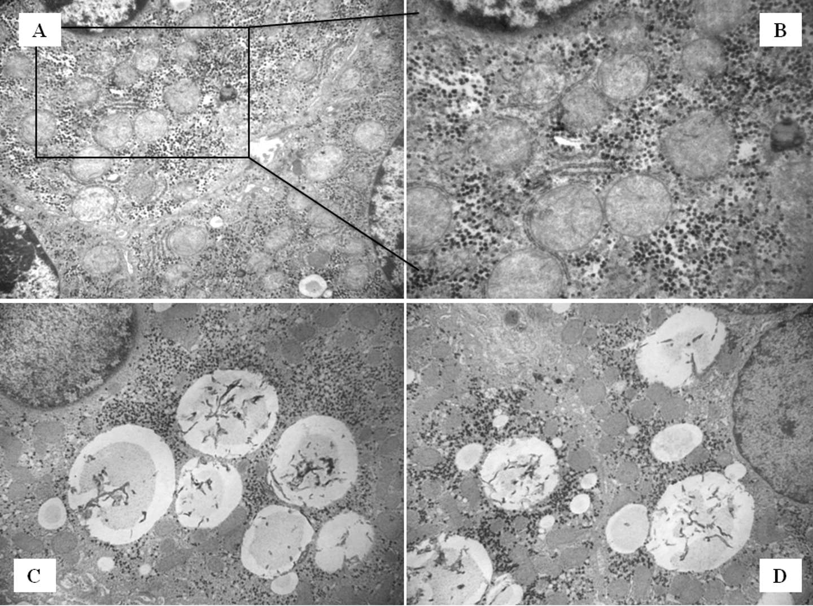
0,45µm

Figure 8-SI. Electron micrographs of CS liver samples 2 hours after implantation: (A) numerous dense bodies in the biliary pole; (B) damaged vessel; (C) activated Kupffer cell; (D) infiltrating neutrophil.





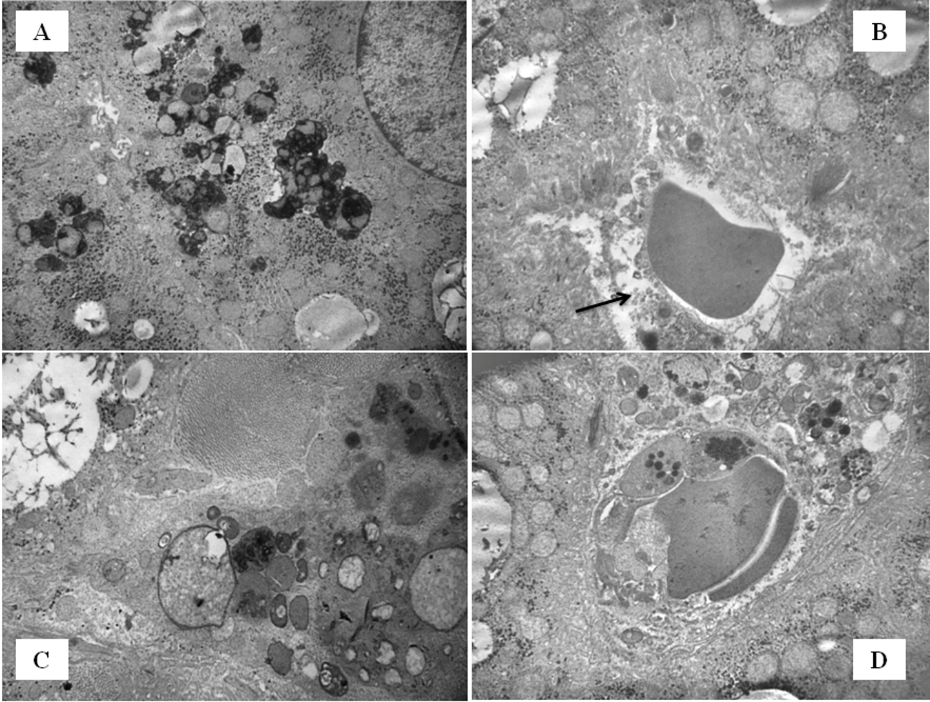

Figure 9-SI. Electron micrographs of NMP liver samples 2 hours after implantation. A,B) mitochondria of normal size; C,D) reduced lipid droplets.




